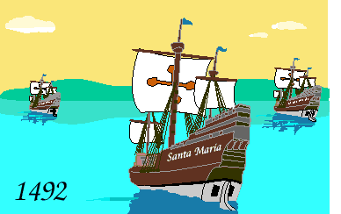

7:00 Executive Session – Assessors, Pending Litigation
Open
Call to Order
7:30 Citizen Comments
Approval of Minutes
Appointments
Old Business
New Business

- One Day License Request from Bartending Service of New England for 11/3/12

- Energy Committee Appointment

- Request to Use Town Common for Live Nativity Scene

- Request from the Women’s Club to hold Turkey Trot Road Race on 11/11/12

- Draft Policies

Declaration of State of Emergency

Flag Lowering

Property Naming and Memorials

Upcoming Meetings
Announcements
Adjournment
Executive Session

Happy Columbus Day!

